**IDENTITY E2E – Test 4 - Java Exercise**

Part 1:

Write a Service layer bean to do the following:

1. Scan configured directory in file system which will return this information --> filename, file mime type, file size, file extension
2. Use a directory containing a reasonably large number of files, minimum 10.
3. Provide a way to retrieve certain supported mime type files: configure excel and csv are supported currently

Part 2:

Write a selenium/cucumber framework to do the following:

1. Use the above service layer bean to get supported files (excel or csv are supported, from input directory)
2. Go through the file and read vehicle registration details in the file.
3. Open webpage : https://www.gov.uk/get-vehicle-information-from-dvla and go through all vehicles from excel/csv file.
4. On the Vehicle details page assert the details (Make/Color) match with expected output in excel/csv file.

Key Requirements:

* Write appropriate Junit tests
* Use of design patterns where appropriate.
* Contain clear and precise logging/comments.
* Provide screenshot of output when you run Part 2 test locally.
* Update all code / documentation to your GitHub account

Implementation Details .

**Part 1:**

For Testing the First part of the exercise, run the FileReader.java. It calls the three methods which returns all files information in a directory, all csv files information in a directory and all excel file information in a directory.

For reporting using the system.out.println to print the output on the console.

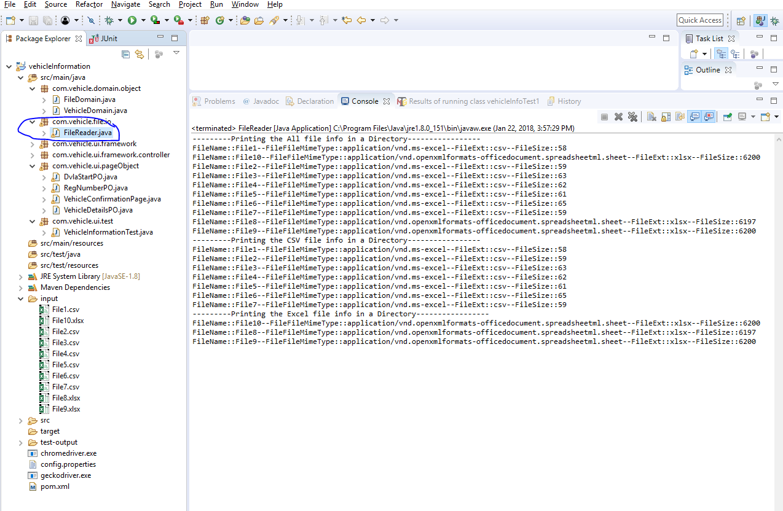

**Part 2:**

TO execute the part 2 run the VehicleInformationTest.java. As part of processing this class will do below things.

1. Read the vehicle data from all csv and excel files.
2. For each vehicle RegNumber run the Junit test case, fetch the RegNumber colour and make information from dvla site and match with the data present in excel or csv files.

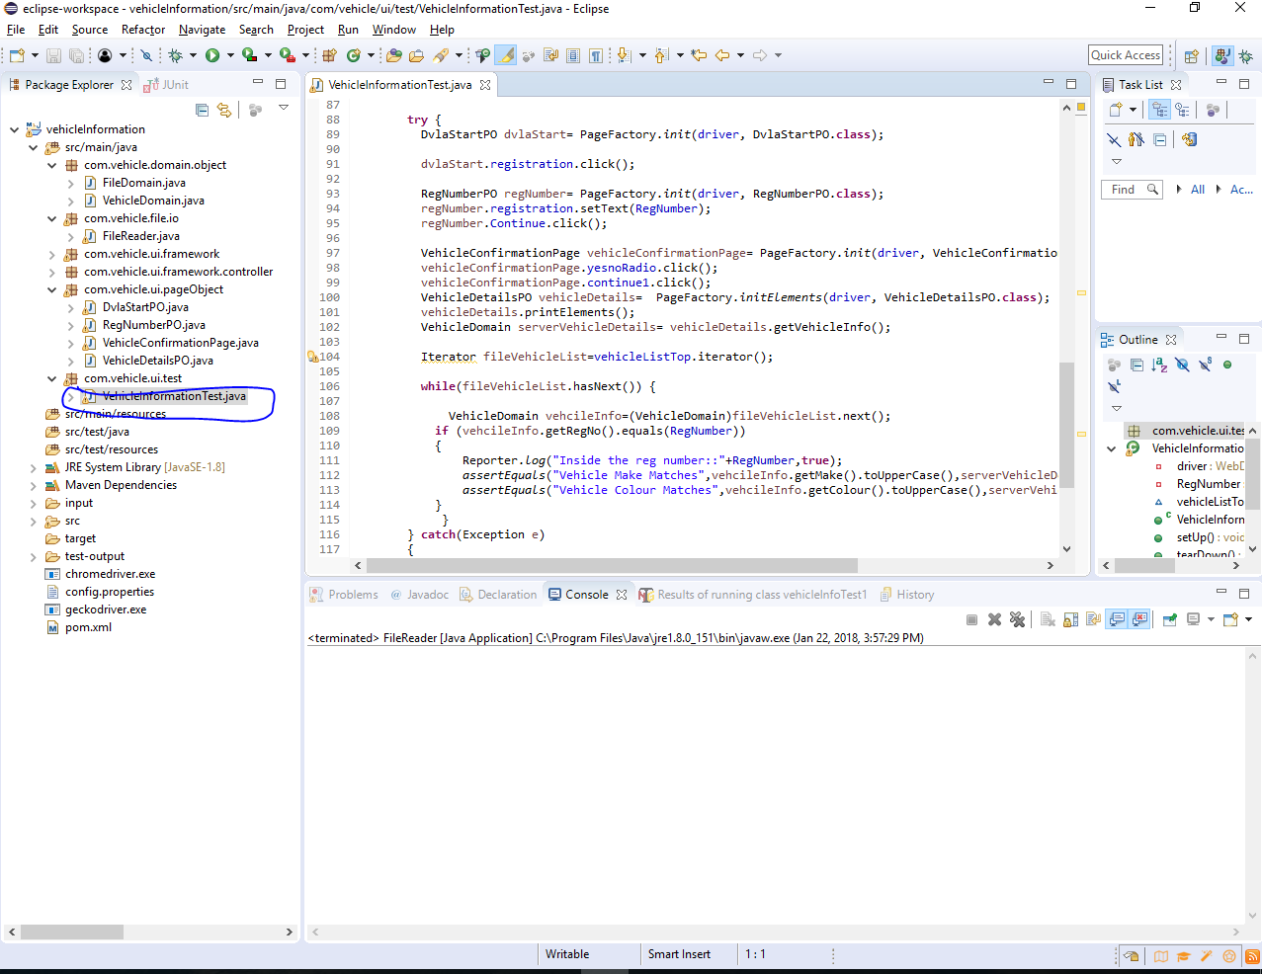

* 

The Junit test run for 20 vehicle records, present in 10 files each file having two records. Showing test passed and failed and failed test assertion message.

* 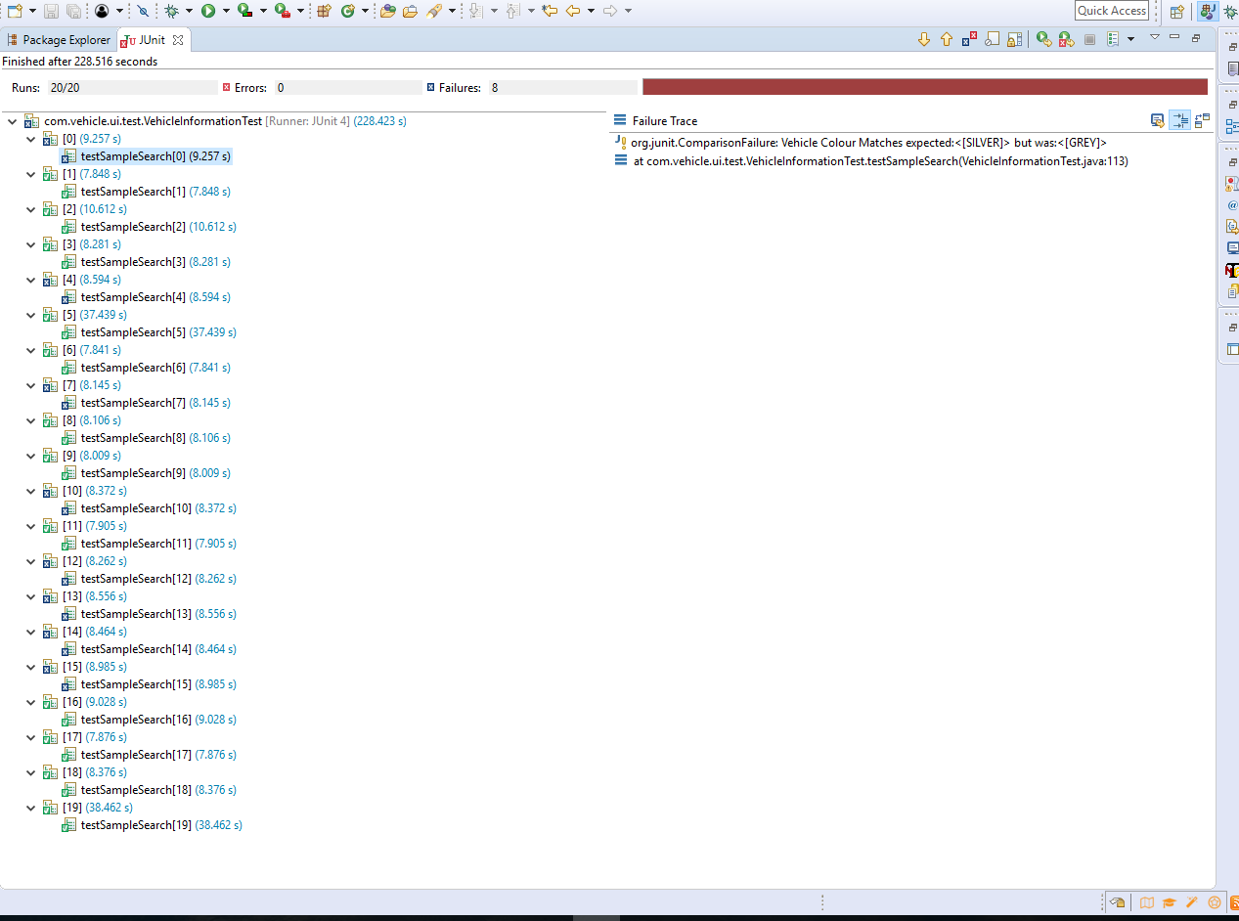

Sample Running of Junit for one vehicle. The Junit is parameterised and run in the same way for rest another vehicles.

